IOTPD 25TH Anniversary Conference
Friday 16th November 2018
Venue: Théâtre Arsenic

10.00 am: Welcome
Alessandra Mattana, Danse Transition and Oliver Dähler, SSUDK

10. 05am: Opening remarks
IOTPD President, Paul Bronkhorst

10.15am: Session 1 – Why the IOTPD? A conversation about the IOTPD’s founding, with:
- Paul Bronkhorst, President of the IOTPD
- Susanne Jaillet, Founder, Danse Transition (formerly RDP)
- Joysanne Sidimus, Founder, Dancer Transition Resource Centre
Conversation facilitated by Garry Neil, DTRC Board member for 25 years and former Chair

11.00am: Session 2 – Taking the Lead, an overview of some IOTPD activities
- IOTPD Transition Centre Toolkit – Jennifer Curry, Dancers’ Career Development (UK)
- IOTPD Philippe Braunschweig Grant – Amanda Hancox, Dancer Transition Resource Centre (CA)
- Dancer Transition Case Book – Mun Ghy Min, Dancers’ Career Development Centre (KR)
- IOTPD Symposia – Paul Bronkhorst, Omscholing Dansers Nederland (NL)
Moderator: Sabrina Sadowska, Stiftung TANZ (DE)
11.45 – 12.00 BREAK
12.00pm: Session 3, Part I – Showcase of transition centre programs
Introduction by: Agnès Wasserman, Centre national de la danse (FR) and Mun Ghy Min
- Canada – on the MOVE program for graduating dance students
- Poland – One-on-one counselling program
- Switzerland – Speed Dating
- United Kingdom – Evolve

1.00 – 2.00pm LUNCH

2.00pm: Session 3 Part II – Showcase of transition centre programs
- Swizerland – Journée Trampoline
- France – Career Transition Tool
- The Netherlands – Transferable Skills
- Korea – Career Transiton Academy program

2.45: Session 4 – A Dancer’s Experience
Four dancers discuss the joys and challenges of transition – both into and from dance performance
- Alexia Casciaro, emerging dance artist
- Tom de Jager, former dancer and assistant logistics planning and production - Royal Ballet of Flanders – studying event management
- Erick Guillard, former dancer and choreographer – designer, leather and textiles
- Kylie Walters, multidisciplinary artist working at the intersection of public health and the arts
Moderator: Amanda Hancox, Dancer Transition Resource Centre (CA)

3.30pm: Session 5 – State of Play, global perspectives, opportunities and challenges.
Panel discussion with IOTPD member countries, and audience Q & A
Moderator: Jennifer Curry, Dancers’ Career Development (UK)

4:45pm: Closing conference remarks – IOTPD President, Paul Bronkhorst

6.00pm RECEPTION and Honouring of Philippe Braunschweig

Guests IOTPD 25TH Anniversary Conference
Friday 16th November 2018
Venue: Théâtre Arsenic

Alexia Casciaro was born on February 17, 1994 in Italy. Passionate about dance she decided at the age of 12 to join the Rosella Hightower High School of Dance in Cannes, directed by Paola Cantalupo. There she trained to become a professional dancer. In this school that she studied classical and modern dance, and later contemporary dance. In September 2014 she joined the Bachelor in Contemporary Dance - creation option - at La Manufacture - High School of Performing Arts of Suisse Romande, under the artistic direction of Thomas Hauert. For three years, she worked with icons of the world of contemporary dance such as: David Zambrano, Deborah Haye, Shelly Senter, Marc Lorimer, Fabrice Mazliah, Thomas Hauert and many others.
Afterwards, she danced in the "Unitile" piece with the choreographer Foofwa d'Immobilité until May 2018. Currently, she takes part in the artistic project "Act in Thought - Six potentialities for TanzPlan Ost" with the choreographer Fabrice Mazliah.
Her interests are not only limited to the field of dance, in September 2017 she started a study at the Holistic Nutrition School (mind-body-mind-approach) in Geneva - distance option, directed by Daniel Dulac until 2020.

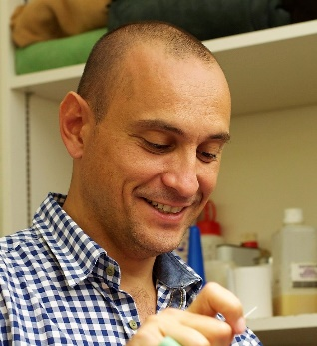
Erick Guillard studied classic dance at the Conservatoire National Supérieur de Musique et de Danse in Paris and was engaged at the Ballet de Lorraine, Komische Oper Berlin, Theater Basel Ballett and Bern Ballett. As a freelance dancer and choreographer he also worked for several companies in Switzerland and abroad. Erick transitioned to a Leather and Textile expert (EFZ/CFC) and designs his own handbags and leather goods and works in his own atelier in Zürich.

Tom de Jager was born in Bogota (Colombia) in 1983 and adopted by Dutch parents. He started dancing at the age of four and followed the preparatory course at the National Ballet Academy in Amsterdam. Afterwards he was offered a scholarship for the Royal Ballet School in London, where he graduated in 2002. During his training he received the McAslans Family Trust prize for 'remarkable talent', as well as the travel and study prize of the Friends of Dutch National Ballet. During his internship at the German Leipziger Ballett of Uwe Scholz he was allowed to dance with the DVD recordings of Le Sacre du Printemps. Tom joined the Royal Ballet of Flanders ballet in 2003. In addition to dance, Tom is responsible for Ballet Vlaanderen's ballet shoes and pointes. He studies event management at Vives Hogeschool in Kortrijk with the support of the Philippe Braunschweig Grant 2016. In August 2018 Tom became a full time assistant Logistics Planning and Production with the company.

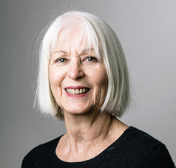
Susanne Jaillet is the founder of Danse-transition in 1993 and has been President of the association from 1993 to 2010. Since then she is Honorary President. During her presidency, she participated in the IOTPD committees as well as in the 1995 Lausanne The Dancer's Destiny and 2004 Monaco The aDvANCE Project symposiums. In 2005, she took part in the "Dance Project" set up by the Federal Office for Culture and Pro Helvetia. She holds a MBA in Cultural, Social and Environmental Economy Management for the presentation of her thesis "From volunteer work to professionalization of the Swiss Association for the Transition of Professional Dancers". Currently, after having been HR Director for 20 years in an IT company, she practices independent business consulting. Susanne Jaillet is married, mother of 2 children and grandmother of 5 grand-children.
Garry Neil has worked 40 years in arts and cultural policy, in Canada and internationally. He has consulted for governments, cultural industry firms and non-governmental organizations and has experience in policies for television, film, publishing, performing arts, visual arts, music, and digital media and the Internet. As Executive Director of the International Network for Cultural Diversity, Mr. Neil was at the forefront of the global campaign which led to the adoption of the 2005 UNESCO Convention on the protection and promotion of the diversity of cultural expressions. He is a member of UNESCO’s Panel of Experts and is leading a global project looking at how UNESCO member states support their artists. Mr. Neil first joined the Board of the Dancer Transition Resource Centre in 1993 and has served as its Chair. He is currently on the board of the Canadian Senior Artists Resource Network and CPAMO, an organization which promotes cultural diversity and pluralism. Mr. Neil’s book on Globalization, Trade and Canadian Culture in the Digital Era will be published by James Lorimer and Co., Publishers in 2019.

Joysanne Sidimus, M.S.M., was born in New York. She trained with George Balanchine and was a dancer with the New York City Ballet, a Soloist with London’s Festival Ballet, and a Principal Dancer with the National Ballet of Canada and the Pennsylvania Ballet. After retiring from performing, she taught and staged Balanchine works for fifteen years and then founded the Dancer Transition Resource Centre and was its Executive Director until December 2005. She was also the founding Vice-Chair of Toronto Western Hospital’s Artists’ Health Centre and Project Director for the Senior Artists Research Project. Ms. Sidimus continues to work as a Balanchine repetiteur for the Balanchine Trust both in Canada and internationally. She is the recipient of both the Governor General’s Meritorious Service Medal and the 2006 Governor General’s Performing Arts Award for Life-time Artistic Achievement.

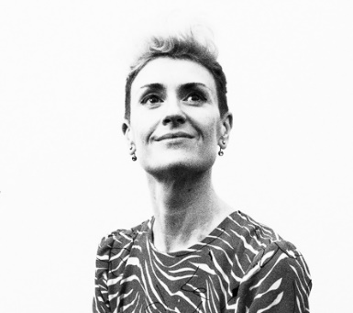
Lyon-based Franco-Australian Kylie Walters holds a Master of Science in Public Health (London School of Hygiene & Tropical Medicine). She has worked as a communications consultant for the World Health Organization (WHO) Global Health Sector Strategy on Viral Hepatitis (2016 – 2021) and the WHO Global Action Plan on HIV Drug Resistance (2017 – 2021). In 2017, with Australian Red Cross International Programs, she contributed to the editing of a Technical Guidance Paper on the Prevention of Violence Against Women and Children (Asia-Pacific region). In parallel, Kylie Walters has 25 years of experience in the performing arts, working with groundbreaking international choreographers and directors including Wim Vandekeybus (Ultima Vez), Tim Etchells (Forced Entertainment) and Lloyd Newson (DV8). As artistic director of the Geneva-based dance company, Ornithorynque, she has choreographed and directed over 10 works. Kylie Walters is a signatory to the SheDecides manifesto. In 2017, she founded the Association Girls just wanna have equal rights, and created She Moves Events.

